Generation of pointillism by motion reconstruction of X and Y axis

Hiroki YAMAGUCHI, Yonguk LEE
Tokyo Polytechnic University
2-9-5 Nakanoku Hontyo
Tokyo, Japan
i1422103 @img.t-kougei.ac.jp

Abstract
In computer graphics(CG) the minimum unit of image formation is a pixel. By manipulating the color and position information of the pixel, image formation becomes possible. Early in CG era is also the history of pixel operation. In the computer, the image is formed by manipulating the X and Y coordinates of the pixel. This research was done to present image formation on computers from the monitor to the outside . This was not only an attempt to physically confirm the image formation on the computer, but it was an attempt to return the information to the outside of the monitor. In this research, the image formation that was made with computer programs was made visible by returning it to some mechanical systems. By doing so, a wonder of image formation was observed.

Keywords-component; pixel, re-photograph, contents
I. Introduction

The aim of this research is to build a new visual image by changing the view of image formation mechanism from inside of the computer to an analogue mechanical system. For the purpose of forming an image, a self-made UpDown device, an image projecter and a camera with slow shooting function were used. By projecting dot motion images and shooting it, the image which cannot be seen in human eyes was shown through the camera eyes. This let the observers experience the process and the fun of image formation.

II. From the devided brush stroke of paintings to drawing with pixels on the computer

There is a difference between the method of making the film image and the computer image. The method of ​making a film needs a capturing of an image as an integration of light, however, the method of drawing with computers needs to divide the object by analyzing it.
Stippling art is very similar to the pixels in the history of image formation. Georges Seurat [1] was a famous new impressionist painter for the stippling art in 19th century.
"Grand Djutto's Sunday afternoon (1884-1886)" (Grand Jatt's Souvenir, Buddha: Un dimanche après-midi à l'Île de la Grande Jatte) (Fig. 1) was his representative work. It is a masterpiece depicting the people who spend the summer day in the middle of the Seine river near Paris by using the stippling method, and it is also a work representing French paintings of the New Impressionist and post-Impressionist era.
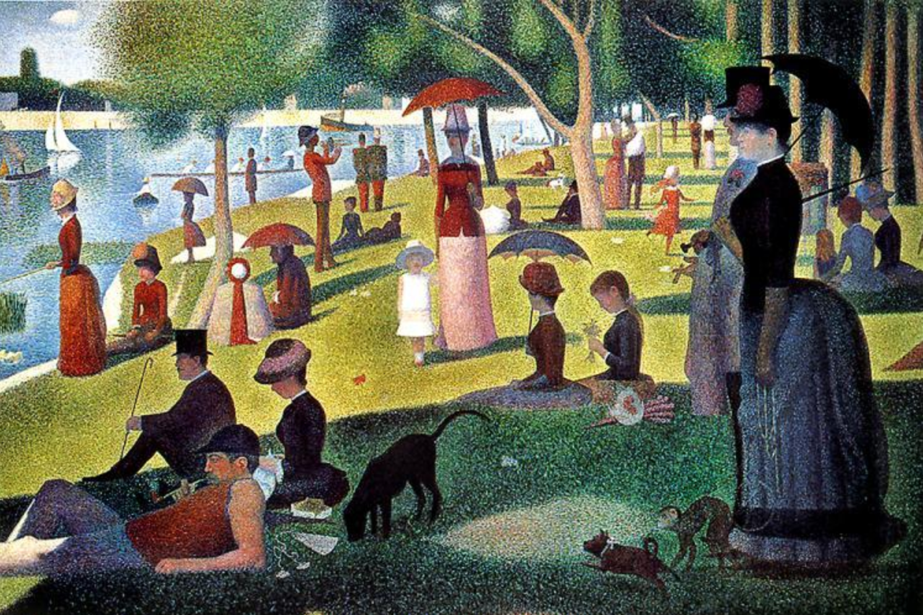
Fig. 1 Georges Seurat "Grand Djutto's Sunday afternoon ".

In Japan, the screen painting by Jakuchu Ito [2], an artist who worked in the Edo period, is famous. In his painting, there is a work done by a method similar to the idea of ​​pixels. First, he drew a grid of the picture frame and then he painted in each grid. This painting process seems similar to the pixels of the computer. His idea is very creative and new, and also it is very close to how computers make images with pixels these days.
It was Kenneth C. Knowlton who generated a computer film using the pixel concept. The “foem field” (Fig. 2) co-drawn by Knowlton and Stan Vandabeek is also a masterpiece of the early computer film [3].
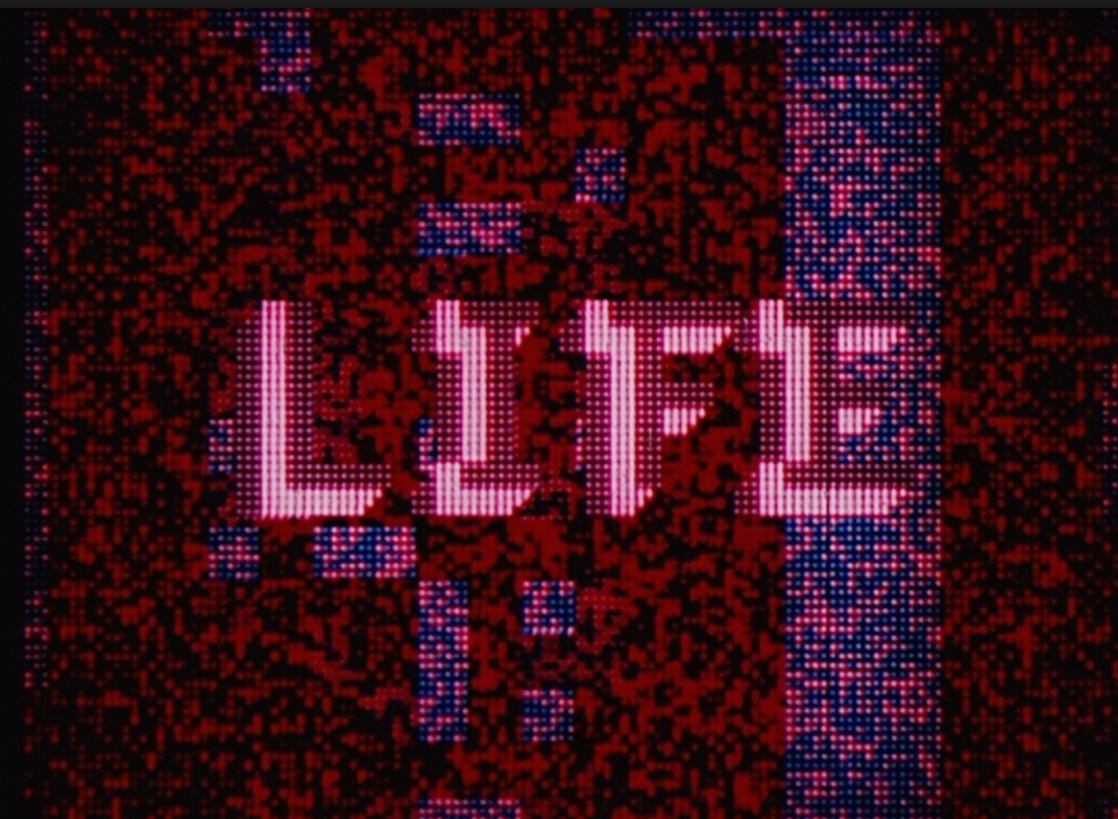
Fig. 2 still image from “ Foem field”

III. Expermental

In this experiment, the picture of Mona Lisa was reproduced in dots. Mona Lisa is a famous symbol of the painting history because Mona Lisa is used in significantly many experiments to create new images. Therefore, Mona Lisa was chosen to be created in this experiment.
In fact, it is an attempt to draw an image with a self-made launching device (we called it “UpDown device”) which repeats the dot image formation restricted to the movement of either the X coordinate only, or the Y coordinate only.
In this research, a picture was drawn by separating to two process. First, a 30 secounds QuickTime movie (Fig. 3) of dot movements in x-axis directions was continueously projected from the UpDown device. After that, the UpDown device was moved in y-axis directions only.

Fig. 3 A part of dot movements movie.

For the experiments, following laboratory tools were used (Fig. 4) , (Fig. 5) .
○ 1 self-made UpDown device: height: 1800 mm. Vertical axis movement device with speed control ability. Continuous loop playback is possible.
○1 projector: Operated with boarding on UpDown device.
○ 1 laptop computer: Used to play the dot movie.
○ 1 digital camera: Capable of opened shutter shooting function.
○ 1 screen of 3m in length and width.
○ 1 HDMI Cable of 4m.

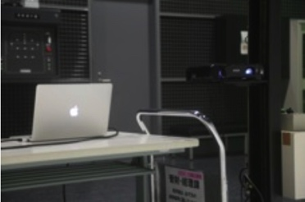
Fig. 4 Laptop Computer, Projector.
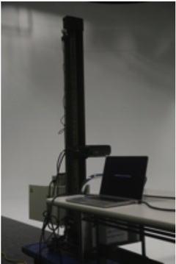
Fig. 5 self-made UpDown Device.

A. Experimental procedure

1. The projector on the UpDown device was installed and the movement was tested .
2.The laptop computer was connected to the projector and the dot image was projected.
3. Dot image was played.
4. The image was shot with a digital camera with an open shutter release.
5. formation image was confirmed.
6. Experiment was repeated.
7. Completion of the experiment and the final check was done.

B. Detailed experiment process

1. A picture of the dot including its horizontal directional moving and blinking information was prepared. It was imported to the laptop computer.
2. A projecter on the UpDown device was set up and it was connected to the laptop computer with the HDMI cable.
3. The UpDown device was started to move. The camera shutter was opened and a series of situations was taken.
4. As a result, the trajectory of the dot which was vertically moved by the UpDown device was shown as the image of the camera taken with slow shutter speed.
5. The image was displayed on the screen and adjustments were made based on it. The shutter speed of the camera was adjusted in regards to the length of the movie.
6. Processes 3 to 5 were repeated.
7. The image of Mona Lisa was completed.

IV. Results
As a result, the following three varying images of Mona Lisa were appeared because of the varying speed of the y-axis falling movement of the UpDown device. The table 1 below summarizes the differences which are the moving distance and the speed.

TABLE I
relationship between Verticle down speed and Moving distance of UpDown divice.

Moving distance(cm/sec) | Y-axis movement time  (second/one way movement) | Obtained image
11.25 | 16 | Fig. 6
6 | 30 | Fig. 7
4.5 | 40 | Fig. 8

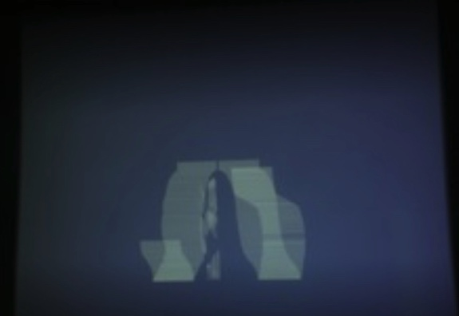
Fig. 6 a result of too fast speed.

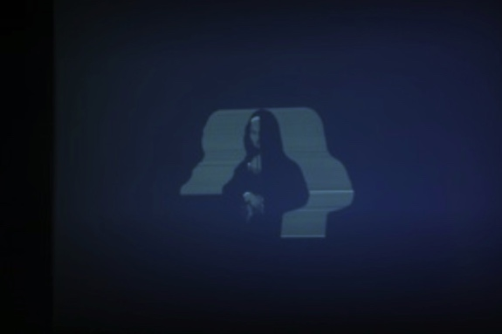
Fig. 7 a result of acceptable speed.

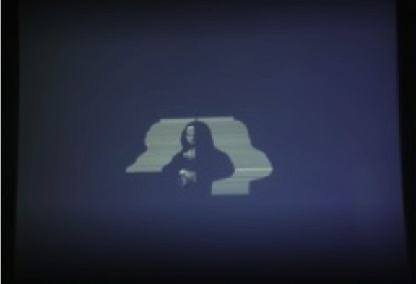
Fig. 8 a result of too slow speed.
1. The final image form is determined by the speed of the UpDown device (vertical movement) + the speed of dot in the moving image (horizontal movement).
2. (Fig. 6 ) image is the result of the too fast speed (vertical movement) of the UpDown device.
3. (Fig. 8)image is the result of the too slow movement of the UpDown device.
4. (Fig. 7) image is the result of the acceptable speed of the UpDown device.

The speed of the horizontal movement of the dots and the vertical movement of the UpDown device affect the accuracy of drawing clearer Mona Lisa. By adjusting the speed of the UpDown device to 6 (cm / sec) this time, more accurate Mona Lisa was observed (Fig. 7). This is a result of moving the UpDown device down for 180cm in 30 seconds.

V. Conclusion

The history of the formation of images has started from a stippled picture and it is followed to the CG made by pixels. This experiment is an attempt to highlight a part of the process of forming a CG image which is usually made by an algorithm in a computer. In other words, a new image can be generation by converting invisible algorithms back to mechanical systems. Specifically, the movement of the X axis is converted into a dot moving image which repeats flickering and moving horizontally. Y axis movement was made with UpDown device. Finally, capturing the image of Mona Lisa was completed by integrating and combining these two objects.

References

- https://en.wikipedia.org/wiki/Georges_Seurat / (30/10/2016).
- Itō Jakuchū (伊藤 若冲 March 1716 – 27 October 1800) was a Japanese painter of the mid-Edo period.
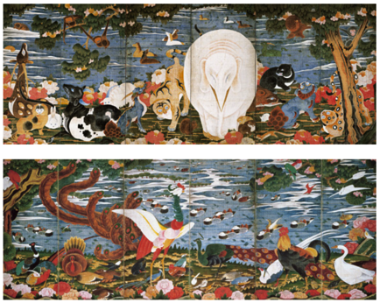
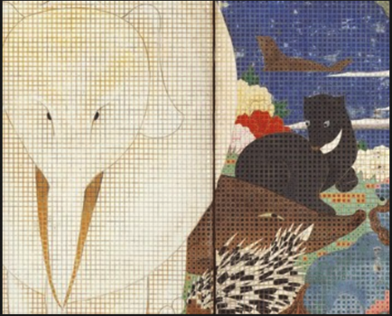
Birds, Animals, and Flowering Plants in Imaginary Scene.
Itō Jakuchū (1716-1800).
Edo Period, 18th century.
Pair of six-panel folding screens, ink and colors on paper.
Each: 168.7 x 374.4 cm.
Courtesy of the Etsuko and Joe Price Collection.
http://bowersmuseum.blogspot.jp/2011/06/ito-jakuchus-m
sterpieces-birds-animals.html (30/10/2016).
- Kenneth C. Knowlton "A Computer Technique for Producing Animated Movies," AFIPS Conf. Proc. 25, pp. 67-87 (Spring 1964).
http://www.kenknowlton.com/ (30/10/2016)
about movie “Foem Fields”:
Gene Youngblood “Expended Cinema,” E.P Dutton & Co, 1970, pp. 246-249.

